|  |  |  |  |
| --- | --- | --- | --- |
|  | Bansilal Ramnath Agarwal Charitable Trust's  Vishwakarma Institute of Information Technology  **Department of**  **Artificial Intelligence and Data Science** | | |
| Student Name: Siddhesh Dilip Khairnar | | | |
| Class: SY | Division: B | | Roll No: 272028 |
| Semester: 3rd | | Academic Year: 2022 - 23 | |
| Subject Name & Code: ADUA21206: Data Visualization | | | |
| Title of Assignment: **Visualize**  **the dataset using temporal category and Timelines tools** | | | |
| Date of Performance: | | Date of Submission: | |

Aim: Visualize the dataset using spatial file and hex map.

Problem Statement:

1. Describe what is spatial dataset.
2. Describe what is shape file (.shp file) and its use.
3. Create Hex map using a spatial dataset and appropriate .shp file. 4.Point out important observations from visualization.

Dataset:

Link: https://[www.kaggle.com/datasets/sagara9595/zomato-pune](http://www.kaggle.com/datasets/sagara9595/zomato-pune)

Background Information:

Dataset:

* 1. So here I taken a dataset of various restaurants in Pune.
  2. Motive of this dataset is we get the clear survey of all restaurants present in pune.
  3. However, I taken the dataset of only 30 restaurants and compared their safety measures, ratings ,5 stars average and etc.

**Dashboard:** A dashboard is a collection of several views, letting you compare a variety of data simultaneously. For example, if you have a set of views that you review every day, you can create a dashboard that displays all the views at once, rather than navigate to separate worksheets.

**USE :** The main use of a dashboard is to show a comprehensive overview of data from different sources. Dashboards are useful for monitoring, measuring, and analyzing relevant data in key areas.

**Advantages:**

1. Building dashboards with Tableau allows even non-technical users to create interactive, real-time visualizations in minutes.
2. In just a few clicks, they can combine data sources, add filters, and drill down into specific information
3. You can categorize dashboards, or rather dashboard goals, into three main types: analytical, operational, and strategic.
4. its primary intention is to provide information at-a-glance, such as KPIs. A dashboard usually sits on its own page and receives information from a linked database.

# Visualizations:

**Observation:** We had created a Dashboard in Tableau of Maximum Possible charts which I had taught in the class. This Dashboard contains all types of charts like line, scatter plot, bubble, bar graph etc.

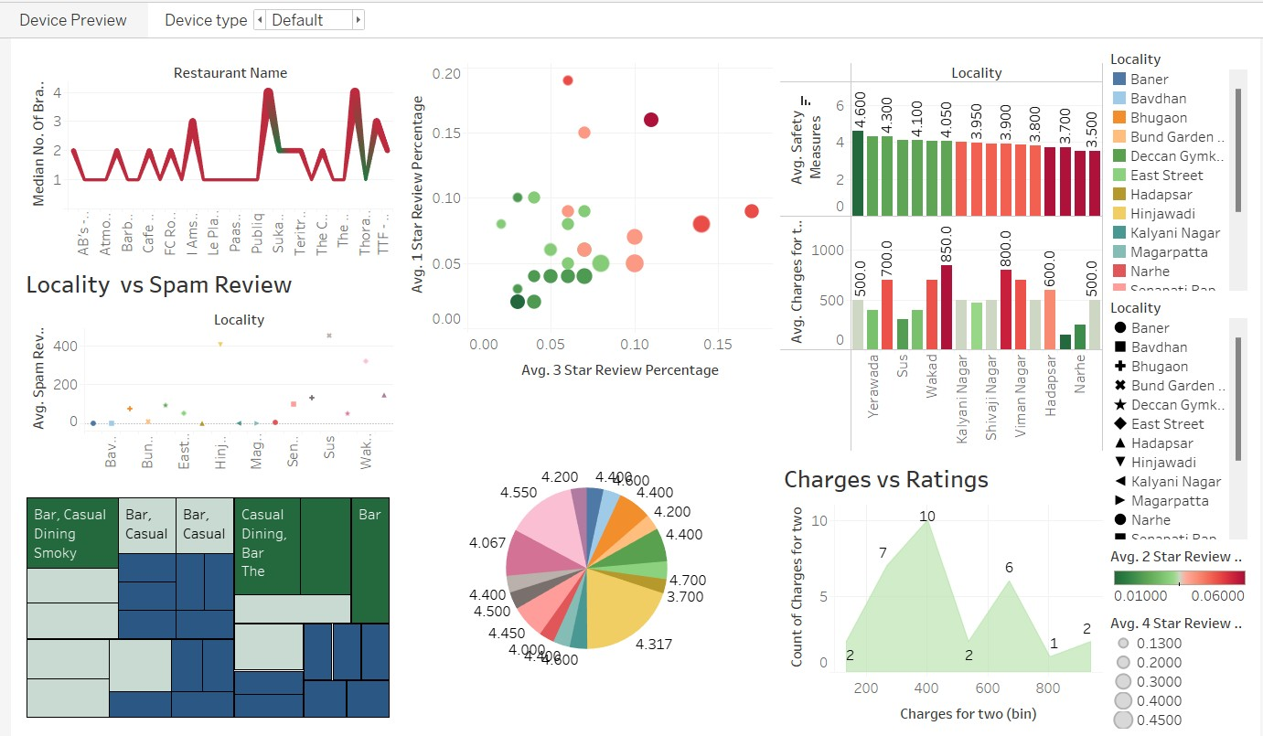

Tableau Link:

[B_28_Siddhesh Khairnar_DV_ASS 10 | Tableau Public](https://public.tableau.com/app/profile/siddhesh.dilip.khairnar/viz/B_28_SiddheshKhairnar_DV_ASS10/Dashboard1)

# Conclusion:

Here we Learned what is the impact and use of Dashboard in tableau. How important it is. I Implemented the dashboard in tableau using the various types of charts I made I implemented all them in a single dashboard. We can able to conclude all the things at one, the color combination, the data to be analysis all get covered in this dashboard. We further discuss about the advantages of the dashboard and much more things and conclude that dashboard is most important tool in the Tableau which can take our data representation to next level.